# CS 255 System Design Document Template

## UML Diagrams

### UML Use Case Diagram

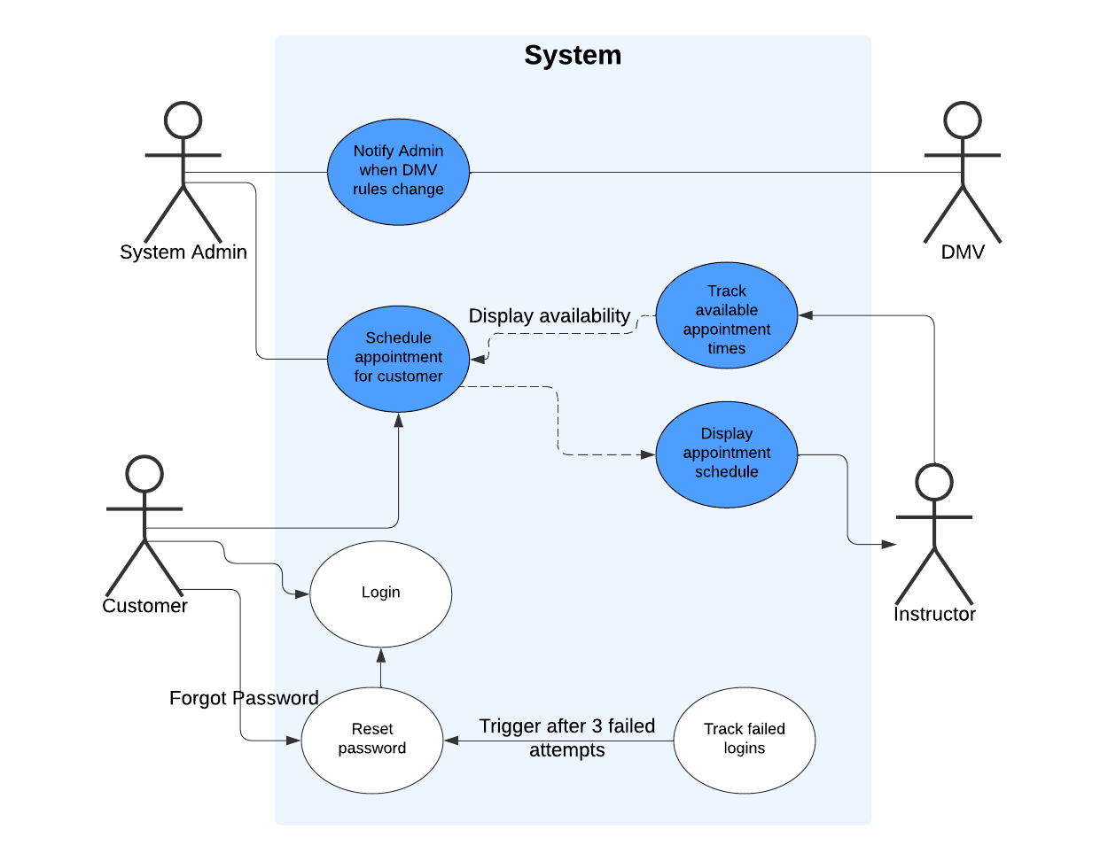

### UML Activity Diagrams

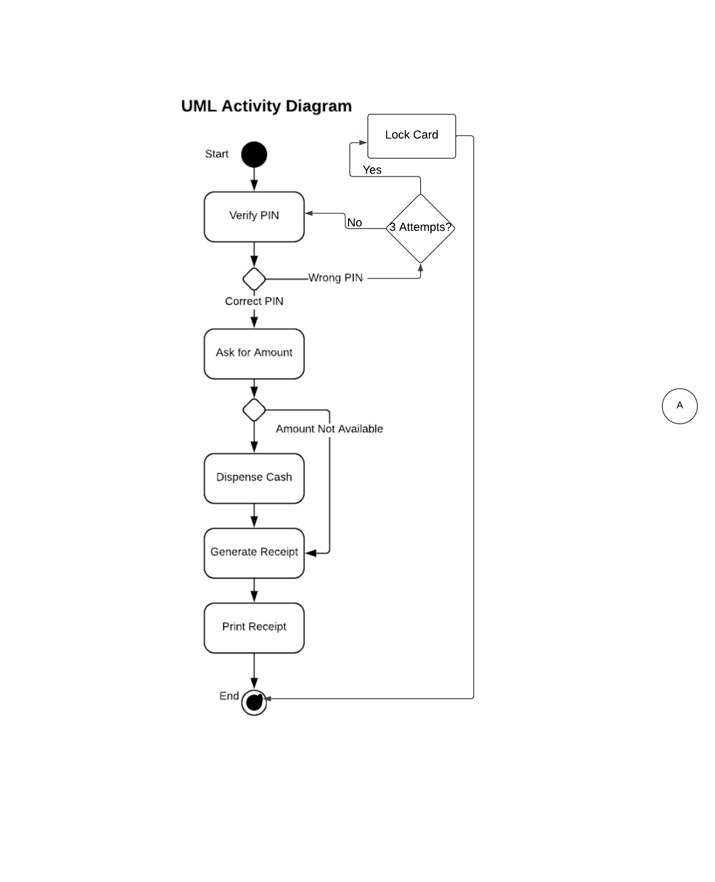

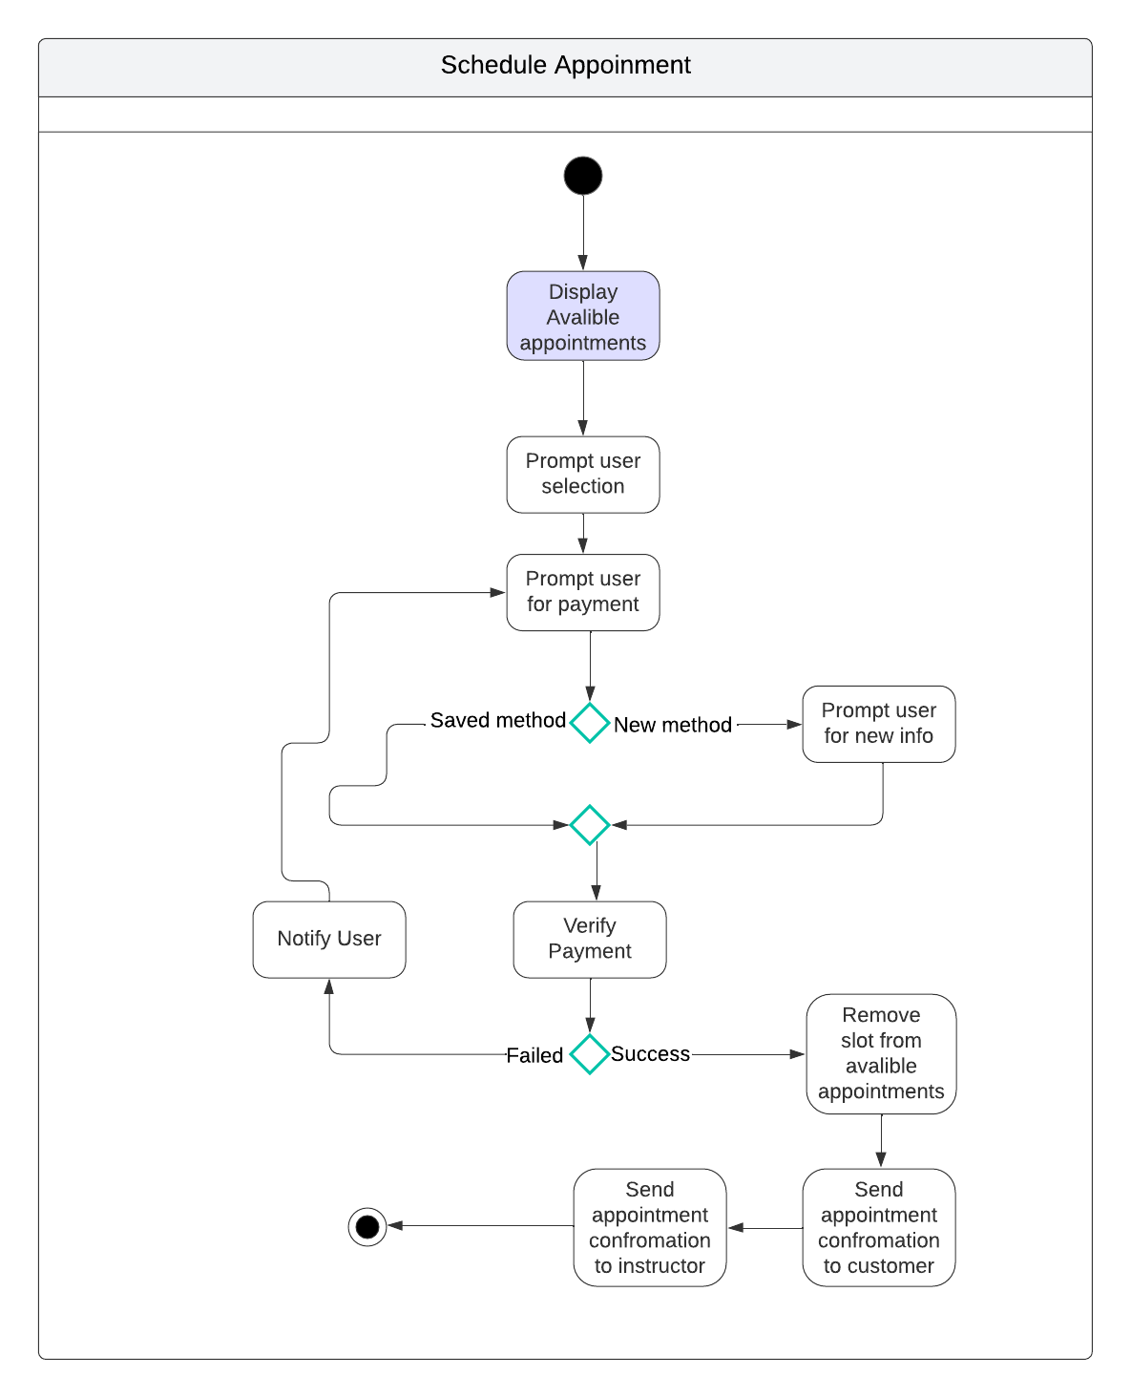

### UML Sequence Diagram

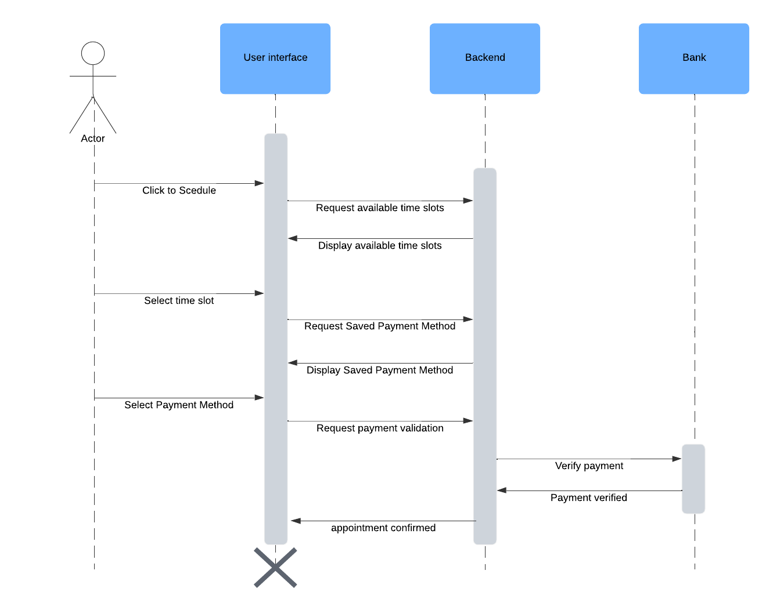

### UML Class Diagram

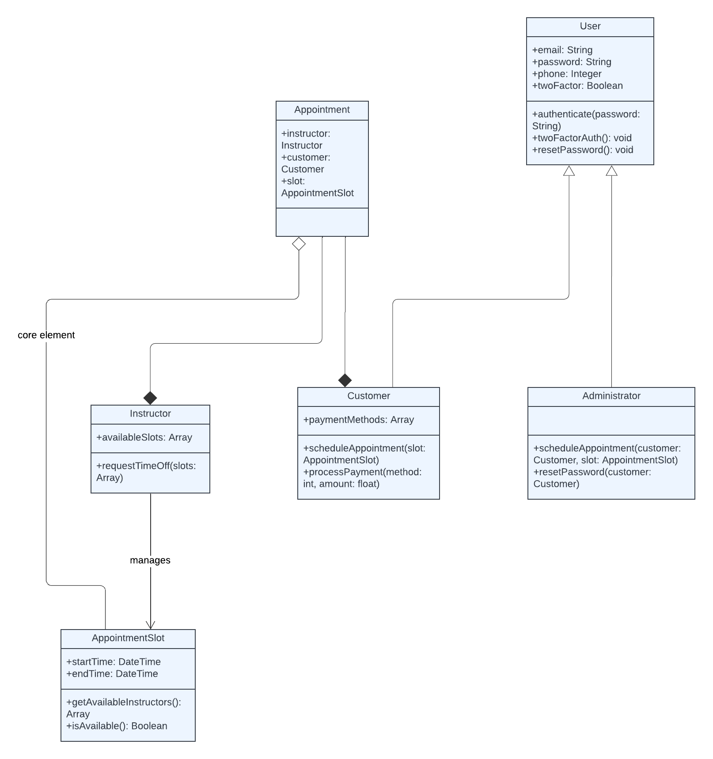

## Technical Requirements

In its hardware, the Driver Pass must use high availability data storage and cloud servers to guarantee reliability and expansibility. Maintenance lies on backup servers to look after itself to be effective and real disaster recovery. Its goal is to allow users on different devices such as desktop, notebook computer, tablet pc or telephone with normal Internet connections complete accessibility.

Concerning software need, it is necessary to support a user-friendly interface at the front end. This will be displayed through webpages designed for mobile browsers - Chrome, Firefox and Safari compatible. It must be able not only to accommodate the diversities of user roles (including customers, administrators, and instructors) but also on both laptop/desktop environments. On the back end, systems must use a cloud database: pairing Amazon Web Services (AWS) RDS with real-time data like user credentials, appointments information, progress tracking and DMV updates are all requirable. Secure back-end API requests to call services such as the DMV or payment provider must pass securely via HTTPS and then always get properly validated from their server-side.

In terms of infrastructure, the system requirements are to be able to run on Windows, Macintosh OS X and mobile platforms like Android and iOS. This is scalability – the system needs to handle more users and functions as our business grows. The platform usefully quickly offers pages-ing three seconds ready out of our servers to give you time for traditional web browsing. Also there must be a push notification in internet browsers featuring the DMV's latest news. To preserve the correctness of your data in case something goes wrong, the system has to do daily automatic backups.

For the DriverPass system, security is a primary concern. The system uses host-based encryption to provide security for data at rest. Strict password rules are required: passwords must have both capital letters and lowercase as well as numbers or other special characters. To improve account safety, two-factor authentication will be implemented in the future. This means that after five unsuccessful login attempts by somebody who has not provided correct credentials, my account should be locked up and reported by the system administration. Encrypted transmission between the client and server ensures user data is safe: all data exchanges must pass securely through HTTPS or other means.

The system must also be flexible enough for administrators to flexibly set up user permissions and roles. They want to be able to add or delete user accounts without having to write code. At the same time if they need a student, tutor, or administrator that user should have certain privileges and access rights which are appropriate for his role inside the program. Furthermore, package descriptions will be able to handle promotions and DMV updates.

For payment processing, the system must integrate a secure payment gateway such as PayPal or stripe, while supporting multiple payment methods. It will also store payment details securely for future transactions. Additionally, the DriverPass platform will maintain high flexibility in order to handle updates to the platform while ensuring continuity of use for all its users.